Dog Behavior
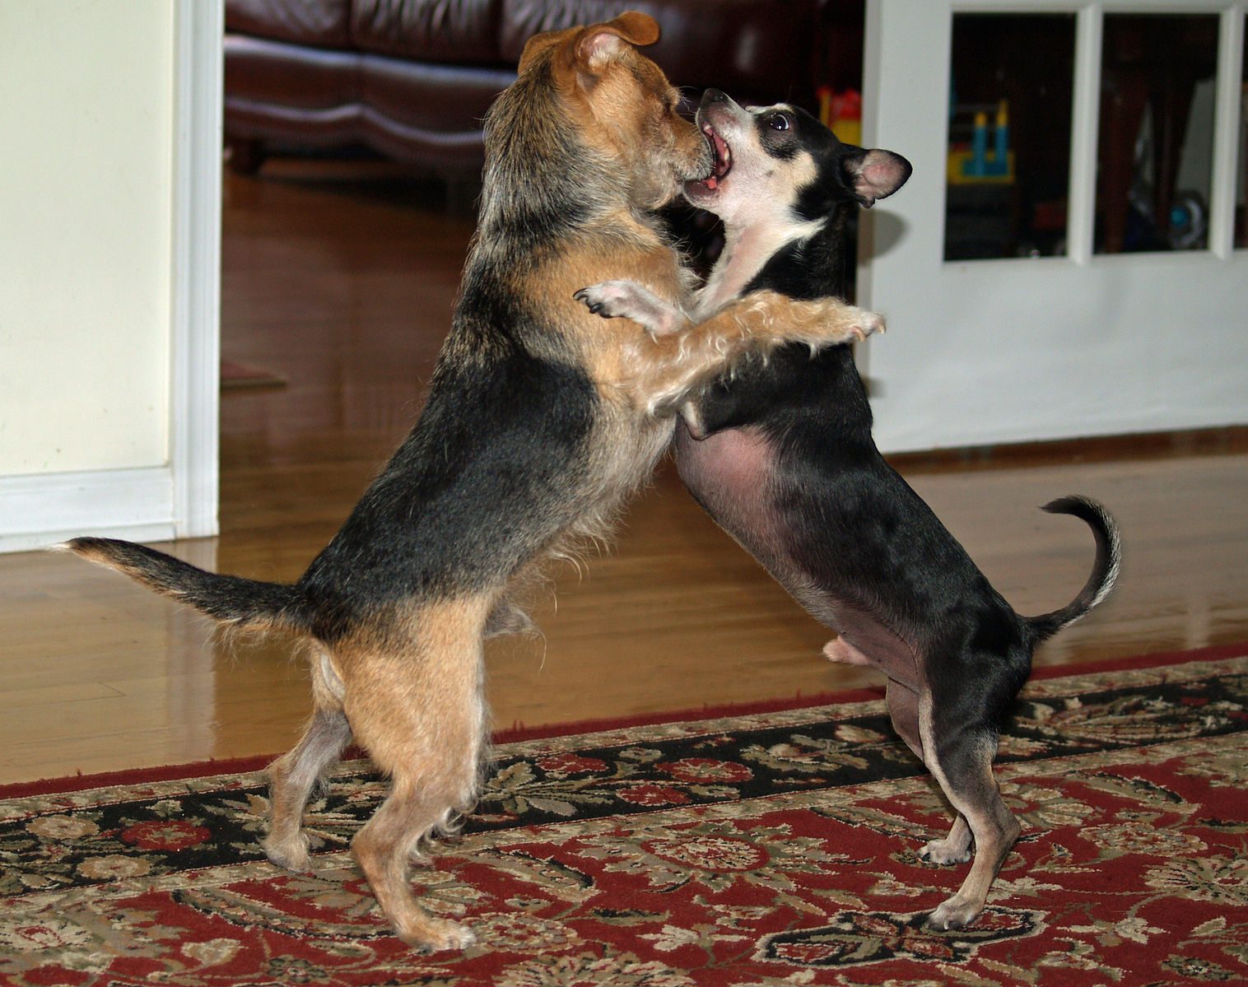

Dog behavior is the internally coordinated responses (actions or inactions) of the domestic dog (individuals or groups) to internal and/or external stimuli. As the oldest domesticated animal species, with estimates ranging from 9,000–30,000 years BCE, the behavior of dogs has inevitably have been shaped by millennia of contact with humans. As a result of this physical and social evolution, dogs, more than any other species, have acquired the ability to understand and communicate with humans and they are uniquely attuned to our behaviors. Behavioral scientists have uncovered a surprising set of social-cognitive abilities in the domestic dog. These abilities are not expressed by the dog's closest canine relatives nor by other mammals such as great apes. Rather, these skills parallel some of the social-cognitive skills of human children.

Communication behavior
Dog communication is about how dogs "speak" to each other, how they understand messages that humans send to them, and how humans can translate the ideas that dogs are trying to transmit. These communication behaviors include eye gaze, facial expression, vocalization, body posture (including movements of bodies and limbs) and gustatory communication (scents, pheromones and taste). Humans communicate with dogs by using vocalization, hand signals and body posture.

Dog behavior can be a big issue. See http://pets.webmd.com/dogs/ss/slideshow-behaviorial-problems-in-dogs to find out more.

Behavior Issues
- Behavior Problems in Older Dogs
- Behavioral Medications for Dogs
- Charging Through Doors
- Compulsive Behavior in Dogs
- Destructive Chewing
- Digging
- Escaping from the Yard
- Puppy Mouthing
- Socializing Your Puppy
- Teaching Your Dog Not to Jump Up on People

Most popular breeds

Position | Breed | Registrations
1 | Labrador Retriever | 123,760
2 | Yorkshire Terrier | 48,346
3 | German Shepherd | 43,575
4 | Golden Retriever | 42,962
5 | Beagle | 39,484

