**SOLUTIONS: Week 6 Practice Worksheet**

**Right Triangles and Non-right Triangles**

**1.** **a.** Find the exact value of all six trig functions for the angles  and  in the triangle in Figure 1. (The triangle may not be drawn to scale.)

|  |  |
| --- | --- |
| First let’s use the Pythagorean Theorem to find *x* | **Figure 1** |

Now, let’s find the value of all six trig functions for the angle :

|  |  |  |
| --- | --- | --- |
|  |  |  |
|  |  |  |

Finally, let’s find the value of all six trig functions for the angle :

|  |  |  |
| --- | --- | --- |
|  |  |  |
|  |  |  |

**b.** Solve the triangle in Figure 1 by finding approximate measurements (in degrees) of angles  and  and the exact length of the side .

|  |  |
| --- | --- |
| In part (**a**) we discovered that .  To find angle  we can use the given information and the sine function (I’m choosing to use sine instead of cosine or tangent since then I can use the given information, rather than information that I’ve derived; this way, if I’ve made a mistake on a previous portion of the problem, it won’t impact this part of the problem):    Now we can find angle  we can use the fact that the total angle measure in a triangle is always : | C:\Users\Pete\AppData\Local\Microsoft\Windows\INetCache\Content.Word\right_triangle_1.png  **Figure 1 (again)** |

**2.** **a.** Find the exact value of all six trig functions for the angles  and  in the triangle in Figure 2. (The triangle may not be drawn to scale.)

|  |  |
| --- | --- |
| First let’s use the Pythagorean Theorem to find *s* :  Now, let’s find the value of all six trig functions for the angle : | C:\Users\Pete\AppData\Local\Microsoft\Windows\INetCache\Content.Word\right_triangle_2.png  **Figure 2** |

|  |  |  |
| --- | --- | --- |
|  |  |  |
|  |  |  |

Finally, let’s find the value of all six trig functions for the angle :

|  |  |  |
| --- | --- | --- |
|  |  |  |
|  |  |  |

**b.** Solve the triangle in Figure 2 by finding approximate measurements (in degrees) of angles and and the exact length of the side *s*.



|  |  |
| --- | --- |
| In part (**a**) we discovered that .  To find angle we can use the given information and the tangent function (I’m choosing to use tangent instead of sine or cosine since then I can use the given information, rather than information that I’ve derived; this way, if I’ve made a mistake on a previous portion of the problem, it won’t impact this part of the problem):    Now we can find angle we can use the fact that the total angle measure in a triangle is always : | C:\Users\Pete\AppData\Local\Microsoft\Windows\INetCache\Content.Word\right_triangle_2.png  **Figure 2 (again)** |

**3.** Find the values of , , and  in the triangle in Figure 3. You should approximate the values (in degrees for the angles) and denote your approximations correctly.

(The triangle may not be drawn to scale.)

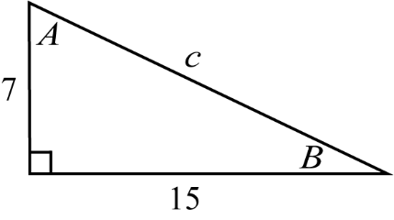

**Figure 3**

First let’s use the Pythagorean Theorem to find the length of the side :



Now we can use the tangent function to get an equation involving angle  and then solve the equation for :



Note that we’ve chosen to use tangent (instead of sine or cosine) to find  since that allows us to use the given side-lengths. If we use sine or cosine, we would need to use the value for  that we found above but it’s possible that we made a mistake so, whenever possible, it’s more sensible rely on the given information rather than on information that we’ve found ourselves.

Finally, we can use the rule that the sum of the angles in a triangle is always  to find angle :



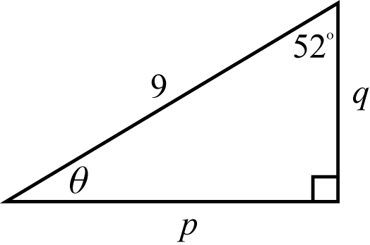

**Figure 4**

**4.** Find the values of , , and  in the triangle in Figure 4. You should approximate the values (in degrees for the angles) and denote your approximations correctly.

(The triangle may not be drawn to scale.)

First we’ll use the rule that the sum of the angles in a triangle is always  to find :



Now we’ll use the sine function to create an equation involving side  and then solve the equation for :



Now we can use the cosine function to get an equation involving angle  and then solve the equation for :



(We can check that  so at least this isn’t an obviously-impossible result!)

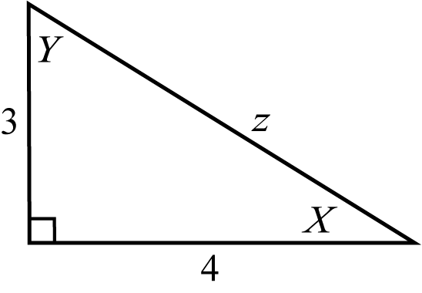

**Figure 5**

**5.** Find the values of  and  in the triangle in Figure 5. You should approximate the values (in degrees for the angles) and denote your approximations correctly.

(The triangle may not be drawn to scale.)

First let’s use the Pythagorean Theorem to find the length of the side 



There are a variety of ways find the angles  and ; here’s one option in which we only use the sine function:

First we’ll use the sine function to get an equation involving angle  and then solve the equation for :



Now we can use the sine function to get an equation involving angle  and then solve the equation for :



(We can check that  so at least this isn’t an obviously-impossible result!)

**6.** Find the values of , , and  in the triangle in Figure 6. You should approximate the values (in degrees for the angles) and denote your approximations correctly.

(The triangle may not be drawn to scale.)

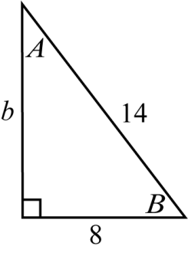

**Figure 6**

First let’s use the Pythagorean Theorem to find the length of the side **:



Now we can use the cosine function to get an equation involving angle  and then solve the equation for :



Note that we’ve chosen to use cosine (instead of sine or tangent) to find  because that allows us to use the given side-lengths. If we use sine or tangent, we would need to use the value for ** that we found above but it’s possible that we made a mistake so, whenever possible, it’s more sensible rely on the given information rather than on information that we’ve found ourselves.

Finally, we can use the rule that the sum of the angles in a triangle is always  to find angle :



**7. a.** , , 

First, let’s draw a sketch of the situation:

**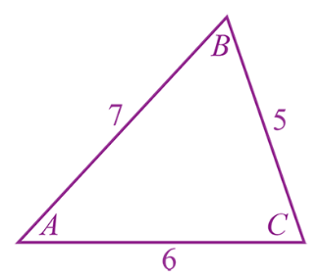**

**Figure 7**

We aren’t given any angle measures so we don’t have any “angle and side opposite” pairs to work with so we cannot employ the Law of Sines, so we’ll have to start with the Law of Cosines which we can use to find any of the angles but let’s aim for :



Now that we know the measure of angle , we have an “angle and side opposite” pair to work with so we can use the Law of Sines to find either of the remaining missing angles; let’s aim for  since it’s opposite a smaller side than is . (Note that it’s always better to use the Law of Sines to find the smaller angle since the inverse-sine function cannot produce angles larger than .)



Finally, we can use the fact that the sum of the angles in a triangle is  to find :



**7. b.** , , 

First, let’s draw a sketch of the situation:

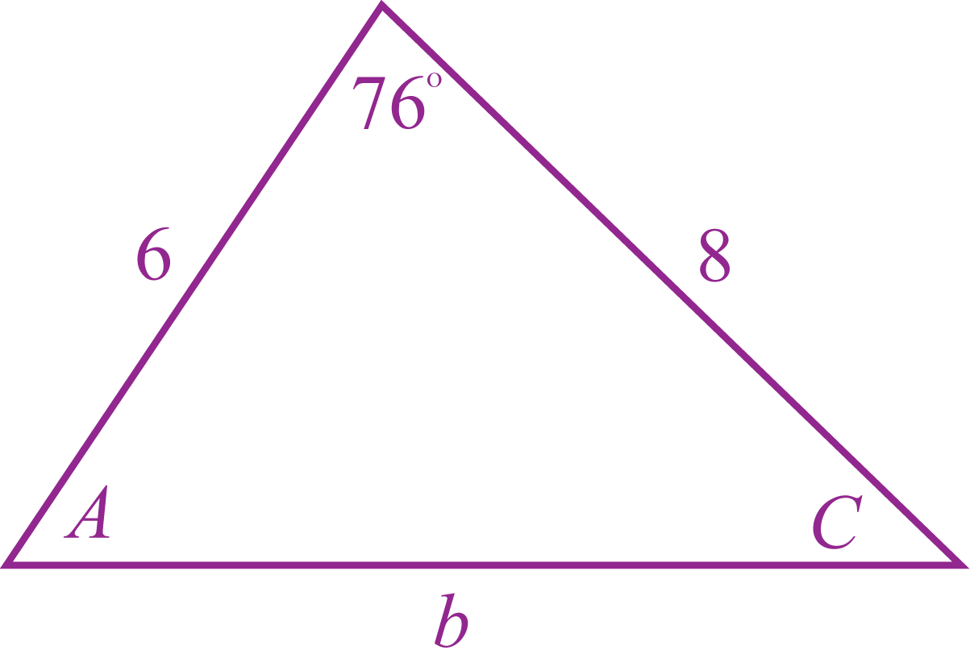

**Figure 8**

As with **4.a.**, we aren’t given an “angle and side opposite” pair to work with so we cannot employ the Law of Sines but we are given the length of the two sides that form the angle  so we can use the Law of Cosines to find :



Now that we know the length of side , we have an “angle and side opposite” pair to work with so we can use the Law of Sines to find either of the remaining missing angles; let’s aim for  since it’s opposite a smaller side than is . (Note that it’s always better to use the Law of Sines to find the smaller angle since the inverse-sine function cannot produce angles larger than .)



Finally, we can use the fact that the sum of the angles in a triangle is  to find :



**7. c.** , , 

First, let’s draw a sketch of the situation:

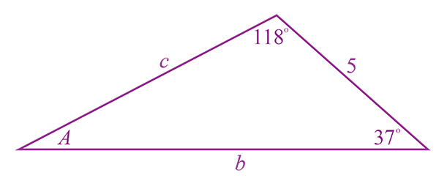

**Figure 9**

First, we can use the fact that the sum of the angles in a triangle is  to find :



Now we have an “angle and side opposite” pair to work with so we can use the Law of Sines to find  and :



and



**7. d.** , , 

First, let’s draw a sketch of the situation:

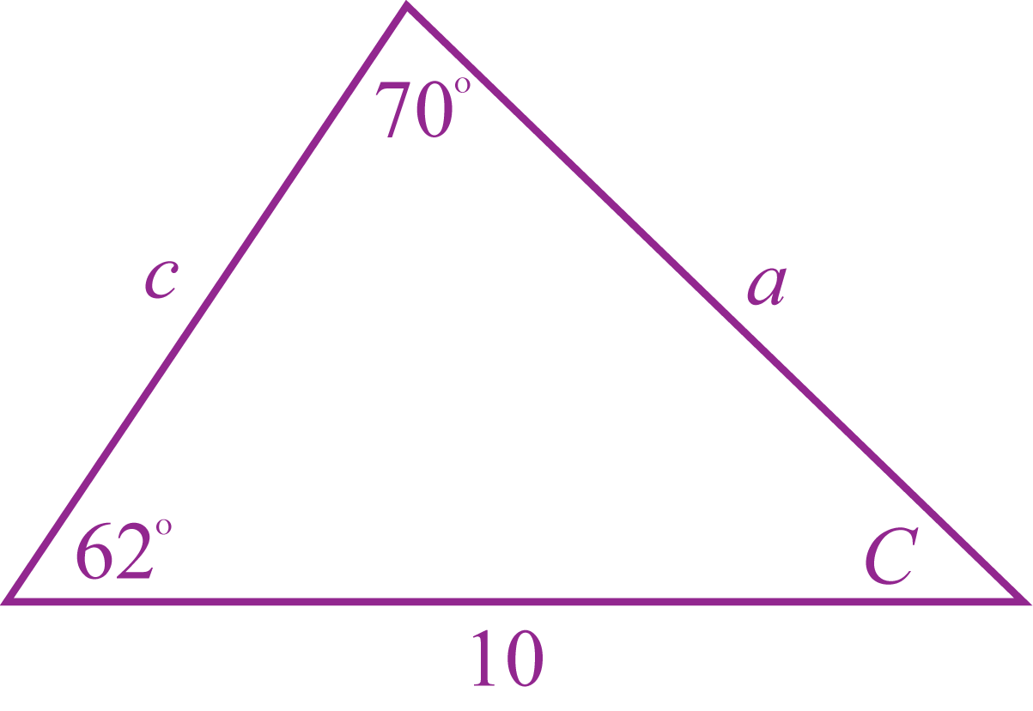

**Figure 10**

First, we can use the fact that the sum of the angles in a triangle is to find :





We have an “angle and side opposite” pair to work with so we can use the Law of Sines to find  and :





and



**7. e.** , , 

First, let’s draw a sketch of the situation:

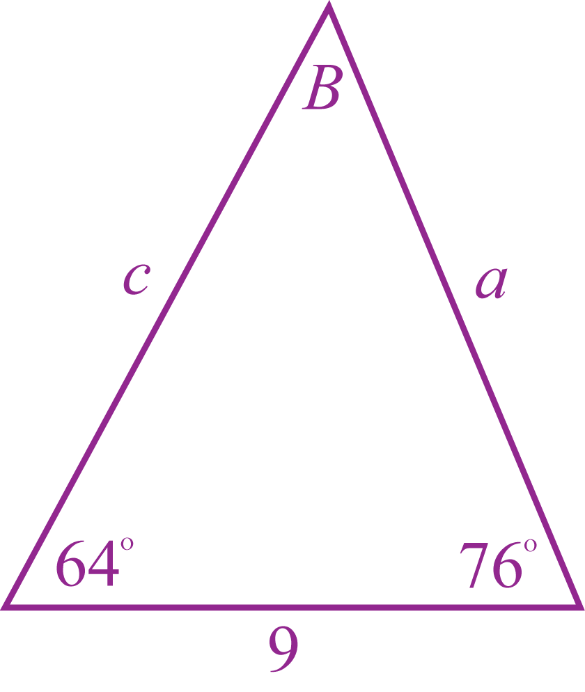

**Figure 11**

First, we can use the fact that the sum of the angles in a triangle is to find :





Now we have an “angle and side opposite” pair to work with so we can use the Law of Sines to find  and :





and



**7. f.** , , 

First, let’s draw a sketch of the situation:

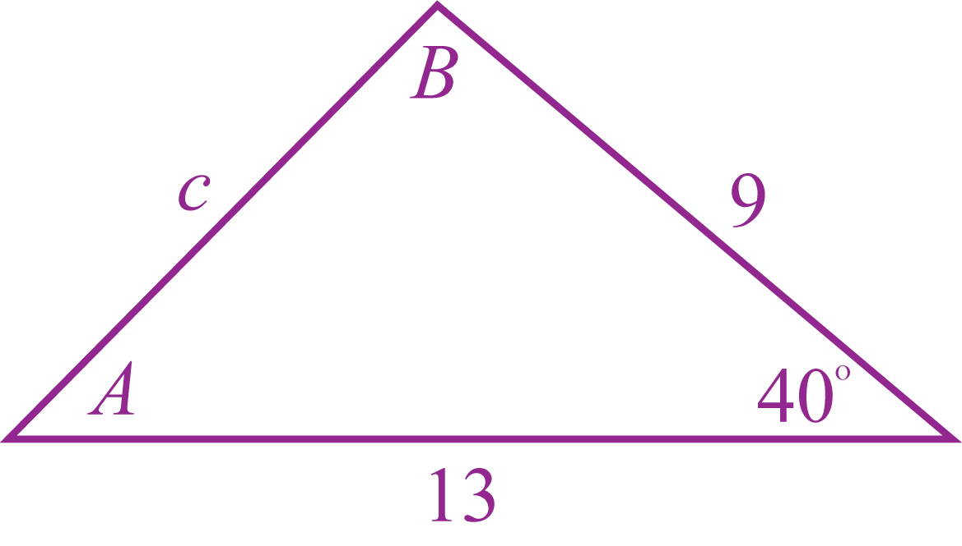

**Figure 12**

As with **7.b.**, we aren’t given an “angle and side opposite” pair to work with so we cannot employ the Law of Sines but we are given the length of the two sides that form the angle  so we can use the Law of Cosines to find :



Now that we know the length of side , we have an “angle and side opposite” pair to work with so we can use the Law of Sines to find either of the remaining missing angles; let’s aim for  since it’s opposite a smaller side than is . (Note that it’s always better to use the Law of Sines to find the smaller angle since the inverse-sine function cannot produce angles larger than . **In this case, if you try to**  **first using the Law of Sines, you will obtain an incorrect measure of** **!!**)





Finally, we can use the fact that the sum of the angles in a triangle is to find :





**7. g.** , , 

First, let’s draw a sketch of the situation:

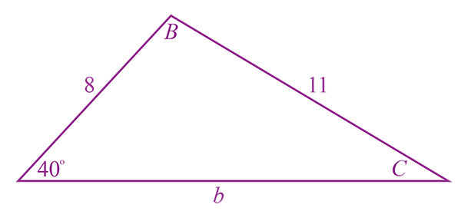

**Figure 13**

To solve the triangle, we can start by using the Law of Sines to find :



Now we can use the fact that the sum of the angles in a triangle is  to find :



Finally, we can use the Law of Sines to find :



**7. h.** , , 

First, let’s draw a sketch of the situation:

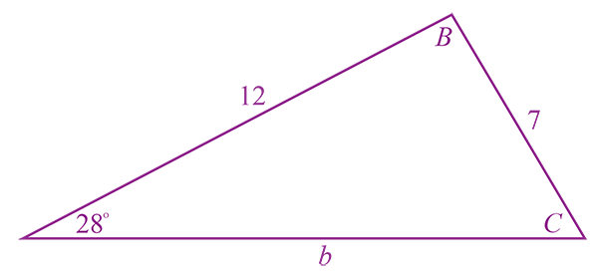

**Figure 14**

Since , the side of length  units can pivot at angle  without changing any of the known info, i.e., there are two different triangles that satisfy the given information. In Figure 15, we’ve drawn both of these triangles, one green and one red. (Compare this situation to **1a**, **1b**, **1c**, and **1d** where any attempt to pivot any of the sides would distort some of the given information so such pivoting isn’t possible and there’s only one possible triangle.)

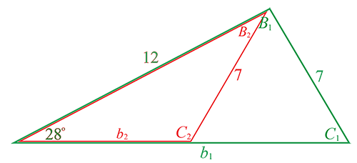

**Figure 15**

Now we can find the values of  and  using the Law of Sines. At the start, we’ll represent the angle with the generic symbol “” and wait to use subscripts until we’re differentiating between the two possible values.



Now we can start distinguishing between  and  so that we can find these two angles. The largest angle that inverse-sine can output is  but  in the red triangle in Figure 15 is clearly greater than : to find  we’ll need to employ the identity :

 or 

To finish, we can solve for the two possible triangles:

Possibility 1: The Green Triangle







Possibility 2: The Red Triangle







**7. i.** , , 

First, let’s draw a sketch of the situation – the sketch shows an “impossible to create triangle” but below we’ll use math to discover that this is in fact the case.

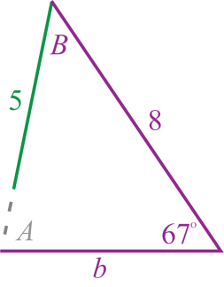

**Figure 16**

Approaching the situation without assuming it’s impossible, we would aim for finding since we have an “angle and side opposite” pair to work with, and we know “”.



If you ask a calculator to give you this value, it will tell you it’s “**undefined**” – it turns out this is because the given conditions are impossible.

The reason  is undefined is that  is greater than 1 (so it’s outside the domain of arcsine), and the reason that this fraction is “too big” is that “5” is “too small” – if the denominator of the fraction were larger, the fraction would be smaller, and then it could be less than 1 and inside the domain of arcsine.

To verify that “” is too short for this side in a triangle with the other given conditions, let’s determine the minimum length of this side. The shortest distance between a line an any point not on the line will be in a direction *perpendicular* to the line – this means that we’ll want to imagine if  were a right angle (i.e., ) and see how long  would be, and that is the smallest possible value for the length of .

|  |  |
| --- | --- |
|  |  |

So  needs to be *at least*  or it isn’t long enough, so the given “” results in an impossible situation

**8.** As you know, a triangle has three sides and three angles: these are the “six components of a triangle.” Notice that in each part of the previous problem (#5) you are given the measurements of **three** of these six components. Sometimes (like in part (a)) you are given the lengths of all three sides; usually you are given a combination of sides and angles; but you aren’t ever given all three angle measures: contemplate, discuss, and explain why.

The three angles in a triangle establish the *shape* of the triangle but, without knowing the length of at least one of the sides, we know nothing about the *size* of the triangle. For example, if the three facts we know about a triangle are that it has angles , , and , the triangle could be any one of *infinitely many* triangles that have these three angles; below are three *different* triangles that all have the same three angles , , and .



