Section II: Trigonometric Identities

Module 6: Modeling with Sinusoidal Functions

Since many real-world scenarios are more complicated than the simple rotation about a unit circle, we often need to modify the sine and cosine functions to use them to model the real-world. As we discussed in Section I: Module 5, we can use simple graph transformations to warp the graphs of and into sinusoidal functions with any period, midline, and amplitude, and (as you've studied in the practice problems in the textbook) we can use these sinusoidal functions to module real-world behavior like the rotation of a Ferris wheel and the oscillation of the rabbit population in a national park. The simple graph transformations work well to allow us to module many real-world scenarios but we need to use other tools to modify a sinusoidal function when we want to model real-world behavior that isn't truly periodic (e.g., an oscillating spring whose amplitude decays over time) and behavior that is more complicated than a simple sine wave (e.g., the combination of multiple sound waves); we'll explore a couple of these tools in this module.

Before we get started, let's first make an important observation about the graphs of sinusoidal functions:

example 1: Consider whose amplitude is 4 units. Notice in Figure 1 that the graph of the function travels between the lines and .

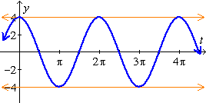
Figure 1: The graph of .

Thus, one way of describing how the amplitude affects the graph is to say that the amplitude determines a pair of lines that guide the graph of the wave.

In the examples below we will investigate the consequence of replacing the amplitude of a sinusoidal function with an algebraic expression.

DAMPED OSCILLATION

example 2a: A weight is suspended from a spring. Suppose that the weight is pulled 4 inches below its resting position and released, and that it bounces up and down once every second without any dampening, i.e., the weight continuously bounces 4 inches above the resting position and 4 inches below the resting positing without losing any energy. Find a sinusoidal function f that models the weight's displacement below its resting position t seconds after it was released.

SOLUTION:

First we need to decide of we want to use sine or cosine to construct our function. Since the weight was at it's maximum displacement below the equilibrium when it was released, it might be easiest to use the cosine function since cosine is at its maximum output when the input is . So our function will have form .

Since the weight bounces up and down once every second (i.e., 1 period in 1 second), the period is 1 second so

Since the weight bounces 4 inches above the resting position and 4 inches below, the amplitude .

Thus, weight's displacement below its resting position seconds after it was released is given by ; we graphed this function above in Figure 1. (Note that "" would give the distance above the resting position.)

example 2b: A weight is suspended from a spring. Suppose that the weight is pulled 4 inches below its resting position and released, and that it bounces up and down once every second. Suppose further that there are damping forces that cause the displacement of the weight to decrease exponentially at the rate of 10% per second. Find a sinusoidal function g that models the weight's displacement below its resting position t seconds after it was released.

SOLUTION:

First we need to decide of we want to use sine or cosine to construct our function. Since the situation is similar to the situation in Example 2a, we can again use a function with the form with .

Unlike in Example 2a, in this example there are damping forces that cause the displacement of the weight to decrease exponentially at the rate of 10% per second. In order to represent these damping forces in the rule for the function, we can replace the amplitude with a function that has initial value and decreases exponentially at the rate of 10% per second. Recall from MTH 111 that

Thus, weight's displacement below its resting position seconds after it was released is given by ; see Figure 2.

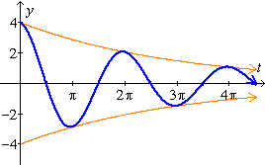
Figure 2: The graph of .

Notice how the curves and play the same role in the graph of as do the lines and in the graph of .

In general, in the graphs of functions of the form and are waves that bounce off of the curves and . I like to think of the curves and as forming a pair of "railroad tracks" that the waves need to fit between.

example 3: Sketch a graph of the function .

SOLUTION:

First let's find our "railroad tracks" that the sine wave will bounce between. The "amplitude-like" function here is so we need to graph and

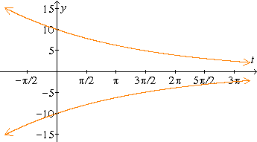
Figure 3: The graphs of and

Since we are graphing , we now need to consider . This is a sinusoidal function with so it's period is . Thus, we need to draw a sine wave that bounces between the orange curves, completing one cycle every units. See Figure 4 below.

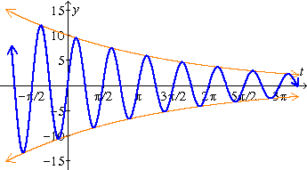
Figure 4: The graph of for

The sum and difference of sine and cosine identities can help explain "acoustic beats" which are used for such things as tuning pianos.

.

