Primary Productivity Lab Assignment and Images
Assignment: Answer the questions based on the images provided.
Do not be afraid of repeating yourself in this lab. You will probably be saying many of the same things over and over again.

Activity #1: Productivity in the Coastal Ocean
Courtesy of the Coastal Zone Color Scanner, NASA
.

Activity #2: Productivity and Water Temperature
Courtesy of the Coastal Zone Color Scanner, NASA

Activity #3: California’s Coast
Courtesy of the SeaWiFS Project, NASA/Goddard Space Flight Center,
and ORBIMAGE www.orbimage.com

Activity #4: The Equator
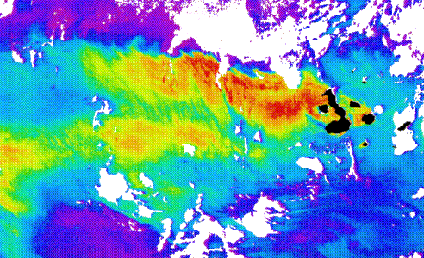
Courtesy of the Coastal Zone Color Scanner, NASA

Activity #5: Blooms & Seasonal Productivity
Courtesy of SeaWiFS and NASA.

