NAME: _______________________________________
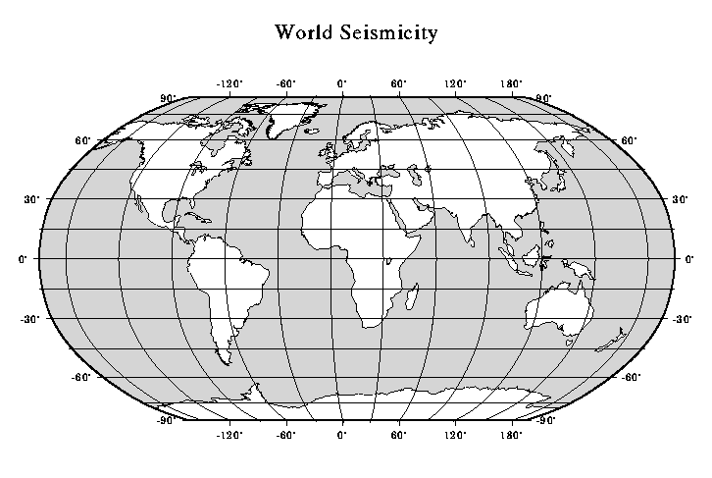Source: http://seismo.berkeley.edu/istat/ex_quake_plot/

