G203 Fossil Poster Project

Purpose: investigate an organism with a fossil record and share your results with your classmates in the form of a poster. You may work individually or with a partner.

Choice of Topic: Choose an organism that you find personally interesting.

Some suggestions:

Oldest fossils corals jawless fish horse fossils
Ediacara Fauna ammonites sharks mammoths
Burgess Shale Fauna brachiopods swimming reptiles saber tooth cats
stromatolites crinoids whale fossils oldest land plant
trilobites dinosaurs sea scorpions first flowering plant

Poster: Your poster should present the summary of your research in an organized and attractive manner. During the poster session the class will divide into two groups, the first group will put up their posters, give a brief (2-3 minute) walk through their poster and answer questions while the other group examines the posters, asks questions and completes evaluations of the posters. Then the two groups will switch roles.

Evaluation: I will evaluate your poster on its presentation and content. For the presentation I will be evaluating the poster’s appearance, organization, formatting (writing, spelling, and references) and how well your answer questions regarding your poster. For content I will be evaluating the posters completeness (see section on organization of poster), your choice of illustrative figures and the quality and detail of information you present.

Point Distribution
The poster project contributes 15% of your course grade and is will be graded on a 15 point scale:

- Poster Presentation 7 points
- Poster Content 7 points
- Peer Review 1 point

Due Dates Organism Selection _________ Presentation ____________
Organization of Poster

Title & Name
Create an informative title which includes your organism’s name.
Keep it short and to the point. Use BIG LETTERS!

Introduction
Include: name of your fossil, common and scientific, taxonomic classification, what’s important/interesting about your organism, why you choose your organism.

Description of Organism
What does your organism look like? What are the parts? How big? Include photos!
How is your organism preserved in the fossil record?

Habitat
What type of environments did your organism live in? (marine or fresh water, shallow or deep water, dry climate or wet climate?) Geographical Range: where is it found?

Lifestyle
What did your organism eat? How did it live? How did it catch its prey? Evade its predators? Colonial, solitary, herds? Any information on reproduction? molting? nesting? migration?

Fossil Record
When was your organism’s day in the sun? How long did it last, is it still with us today? If it is extinct do we know what caused its extinction? Where can fossils of your organism be found? Are their any exceptional localites?

Evolutionary Significance
What did it evolve from? What did evolve into? What evolutionary adaptations did the organism utilize?

Special Features
Anything unusual about your organism? Economic/scientific importance?

Summary
In a series of bullet points highlight the key points of your poster and indicate why your organism is important.

List of References
Include at least three, including at least one book and no more than one encyclopedia article. List alphabetically by author’s last name and include title, place of publication and year of publication. For web sites include title of web page, author, full URL and date of access.

Poster Should Include:

- Taxonomic classification of your organism
- At least one photograph of a fossil of your organism
- Diagram of your organism with key parts labeled
- Photograph of living relative of your organism in its habitat or a drawing of your organism in its habitat
- At least one map; maps showing the geographical distribution of your organism and maps showing key fossil localities are especially informative.

Sample Poster Layout: Use a full size trifold poster board (36” by 48”).
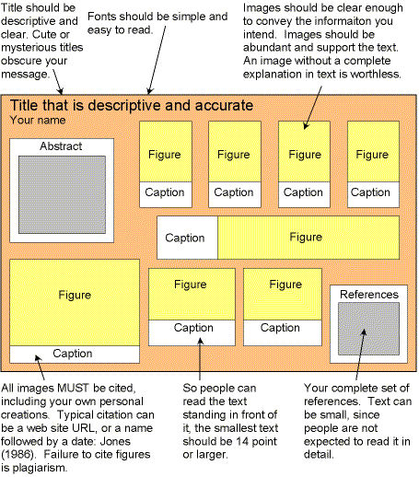
Conclusion

Introduction

