**Math 20 Activity Packet**

Open Educational Resource

Portland Community College

Version 1.1

July 10, 2017

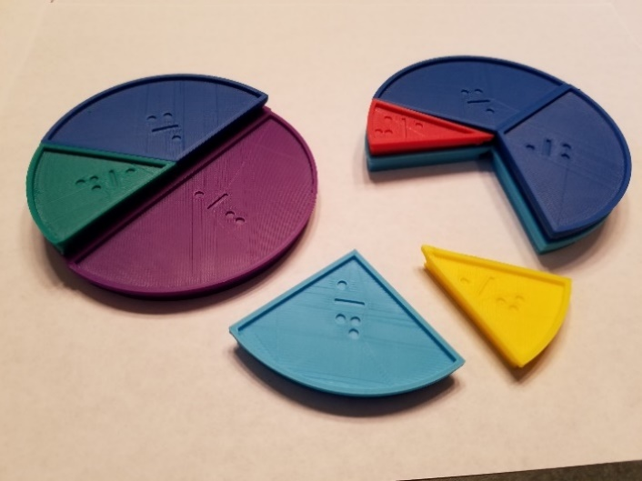

[Creative Commons License](http://creativecommons.org/licenses/by-sa/4.0/)

This work is licensed by Portland Community College under a [Creative Commons Attribution-ShareAlike 4.0 International License](http://creativecommons.org/licenses/by-sa/4.0/).

# **Chapter 0 – Instructor Guide and Sample Lesson Plan**

Contents

Chapter 0 – Instructor Guide and Sample Lesson Plan 2

Acknowledgements 2

Introduction 3

Notes to the instructor 4

Accessibility and Universal Design Features 5

Math 20 Sample Calendar – Fall Term (11 weeks) 6

Sample Homework List, From Basic College Mathematics with Early Integers, Tussy, 5th Edition 7

Math 20 Sample Lesson Plan – Fall Term (11 weeks) 9

## Acknowledgements

This project has been a collaborative effort between the Math Subject Area Committee and Disability Services at Portland Community College.

Math Instructors:

Cara Lee, Jeff Lacks, Bret Rickman, Kim Neuberger, Autumn Pham, Kara Colley, Brenda Bradley, Nicole Kraft and Amanda Uerlings

For questions about the activities, please contact [cara.lee@pcc.edu](mailto:cara.lee@pcc.edu)

Disability Services:

Kaela Parks, Haris Gunadi, Tanner Loveless

For questions about the accessibility features and 3D printed fraction circles, please contact [kaela.parks@pcc.edu](mailto:kaela.parks@pcc.edu)

## Introduction

This is a free, open educational resource designed by Math Instructors and Disability Services at Portland Community College. Please use as many of the activities as you wish and share this with others.

**On the website site (link coming soon)**

* The html with MathML version which can be scaled and used with assistive technology to meet student needs
* PDF files of the activities to download (for print only)
* Microsoft Word files that can be downloaded and edited (created with MathType)
* Braille Ready files
* Source files for the 3D printed fraction circle kits
* Links to read more about Math Player and NVDA Screen Reader

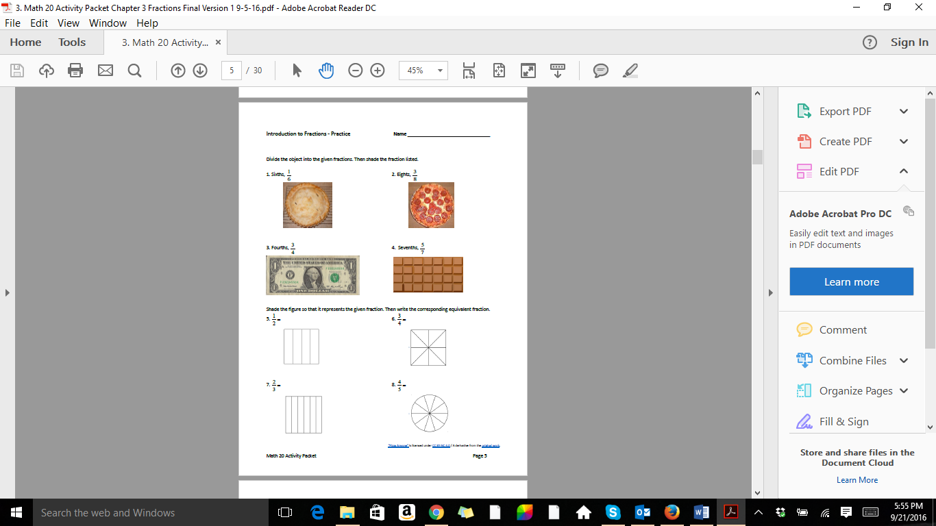  
**Types of Activities**

* Guided discovery or inquiry to introduce a topic
* Practice worksheets
* Games
* Review activities

**Benefits**

* Ready-to-go activities to use in the classroom
* Common activities to encourage more consistency between sections
* Hands-on activities and variety to meet the needs of multiple learning styles and abilities
* Group work and guided activities to increase learner engagement, empowerment and retention
* Prepares students for multiple pathways: Math Literacy, Algebra and Career and Technical Education
* Accessible on the front-end to reduce delays for learners who need alternate formats

**Questions and Feedback**

We would like to help you use these activities with your students

* For questions about the activities, contact [cara.lee@pcc.edu](mailto:cara.lee@pcc.edu)
* For questions about the accessibility features and 3D printed fraction circles, contact [kaela.parks@pcc.edu](mailto:kaela.parks@pcc.edu)

## Notes to the instructor

**Order of the Content**

Number theory topics that are often covered in chapter 1 are placed with fractions in chapter 3 where the skills will be used. Primes and divisibility rules are placed with reducing fractions. The least common multiple is placed with adding and subtracting fractions. You may reorder this if you wish.

Portland Community College places integers after whole numbers and before fractions. This is to give students more time to practice their sign rules and to practice them with fractions and decimals. You may reorder this if you wish, but note that there are negative signs in the fraction and decimal chapters.

**Manipulatives**

Several of the activities use manipulatives for hands-on learning.

If you teach at PCC, there are class sets of manipulatives at each campus and center (Two sets at SY, SE, RC and CA, and one class set each for NB and HB.) Check with your Department Chair for location.

For instructors at other colleges, the source files are available for you to make your own sets, and some items are commonly available.

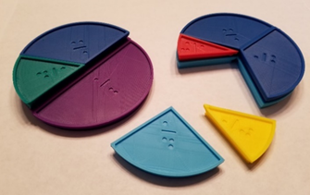Manipulatives to produce for each class set:

* 8 fraction circle kits - designed and produced for PCC by Disability Services
* 12 decks of fraction, decimal, percent cards
* 12 sets of median cards

Other materials needed:

* 8 decks of standard playing cards
* 36 standard 6-sided dice
* 20 Paperclips
* Colored pencils

## Accessibility and Universal Design Features

The HTML version is intended to meet or exceed all web accessibility standards. If you encounter an accessibility issue, please report it to the editor.

* All graphs and images should have meaningful alt text that communicates what a sighted person would see, without necessarily giving away anything that is intended to be deduced from the image.
* All math content is rendered using MathJax. MathJax has a contextual menu that can be accessed in several ways, depending on what operating system and browser you are using. The most common way is to right-click or control-click on some piece of math content.
* In the MathJax contextual menu, you may set options for triggering a zoom effect on math content, and also by what factor the zoom will be.
* If you change the MathJax renderer to MathML, then a screen reader will generally have success verbalizing the math content.

**Connections to Universal Design**

By making learning materials and activities robust and flexible, we can reduce the need for individual accommodation. Key concepts in Universal Design include:

* Giving students multiple representations of key content (verbal, written, tactile, etc.)
* Providing a variety of ways for students to engage with materials and with each other
* Allowing a range of opportunities for students to demonstrate mastery

By making materials available in html with MathML we ensure:

* Students can easily zoom in and magnify
* Students can hear the narrative as well as the math read aloud properly
* Students who use Braille can access the content on refreshable displays directly
* Students who are learning English can easily translate or lookup words

In addition to the files provided here, there are also a variety of additional techniques to support learners. Faculty using this resource should also consult with access technologists on their campuses.

**Tips for Assistive Technology (AT) Users**

Browsers and AT applications change frequently. For best results, please use the Math Support Finder from Benetech to verify which combinations will work for particular platforms <https://msf.mathmlcloud.org/>

## Math 20 Sample Calendar – Fall Term (11 weeks)

Includes arithmetic and problem solving review. LCM and GCF placed with fractions

|  |  |  |
| --- | --- | --- |
|  | **Monday** | **Wednesday** |
| Sept 26, 28  Week 1 | Course Introduction  1.2 - 1.5, Exponents (1.7) | ***Quiz 1***  1.6, 1.9 |
| Oct 3, 5  Week 2 | 2.1, 2.2 | ***Quiz 2***  2.3, 2.4 |
| Oct 10, 12  Week 3 | 2.5, 2.6 | ***Quiz 3***  3.1 |
| Oct 17, 19  Week 4 | Tools for Simplifying Fractions  Divisibility Rules (1.5),  Primes (1.7), GCF (1.8) | **Quiz 4**  3.2, 3.3 |
| Oct 24, 26  Week 5 | ***Midterm 1***  (Chap 1-3.3) | ***Inservice Day***  ***No classes before 4pm*** |
| Oct 31, Nov 2  Week 6 | 3.4, LCD (1.8) | ***Quiz 5***  3.5, 3.7 |
| Nov 7, 9  Week 7 | 4.1, 4.2 | ***Quiz 6***  4.3, 4.4 |
| Nov 14, 16  Week 8 | ***Midterm 2***  (Chap 3-4.4) | 4.5, 4.6 |
| Nov 21, 23  Week 9 | 5.1, 5.2 | ***Quiz 7***  5.3, 5.4 |
| Nov 28, 30  Week 10 | 6.1, 6.2 | ***Quiz 8***  6.3, 7.1 |
| Dec 5, 7  Week 11 | 7.2, 9.7 | ***Quiz 9***  Review for Final |
| Dec 12, 14  Finals Week | ***Final Exam***  (Cumulative) | No Class |

**Tentative Calendar:** Read the indicated sections before class and complete the homework after class. If you have more than 1 or 2 questions, go to the learning center before the next class. This schedule may change during the term due to the class, weather or institutional closures. Be in class for any changes to the schedule or homework, or contact a class member or the instructor if you are absent.

## Sample Homework List, From Basic College Mathematics with Early Integers, Tussy, 5th Edition

|  |  |  |
| --- | --- | --- |
| **Section** | **Page and Description** | **Homework Problems** |
| **\*\*\*** | **NO CALCULATOR** | **USE YOUR CALCULATOR TO CHECK YOUR WORK ONLY** |
|  | **Chapter 1** | **Whole Numbers** |
| 1.2-1.5  1.7 | Arithmetic Review  Exponents | 1.2: 21-25 odd, 29, 33-37 odd, 41, 43  1.3: 15, 19, 23, 25, 29, 33, 37, 63, 69  1.4: 17, 21, 25, 31, 37, 43, 57, 77  1.5: 27-33 odd, 39, 55, 65, 77  1.7: 77-91 odd |
| 1.6 | Problem Solving | 3-11 odd, 15, 17-27 odd, 29, 31, 35, 37, 39, 43 |
| 1.9 | Order of Operations | 11, 19, 23, 27, 31, 35, 39, 43, 45, 47, 51, 59, 63, 67, 71, 75, 79, 89, 101, 105, 109, 113 |
|  | **Chapter 2** | **Integers – Positive and Negative Numbers** |
| 2.1 | Intro to Integers | 1-7 odd, 11, 17, 23, 25, 31- 73 odd, 83, 85, 90 |
| 2.2 | Adding Integers | 5, 7, 19, 23, 27, 31, 35, 39, 43, 47, 51, 55, 59, 63, 67, 71, 75, 79, 83, 85, 87, 89, 95 |
| 2.3 | Subtracting Integers | 15, 17, 21, 25, 29, 33, 37, 41, 45, 49, 53, 57, 61, 65, 69, 73, 77, 81, 85, 89, 93, 101 |
| 2.4 | Multiplying Integers | 1, 5, 9, 13, 15, 21, 25, 29, 33, 37, 41, 45, 49, 53, 57, 61, 65, 69, 73, 77, 81, 85, 89, 93, 101, 105, 107 |
| 2.5 | Dividing Integers | 7, 9, 13-35 odd, 45-65 odd, 81, 83 |
| 2.6 | Order of Operations | 13-31 odd, 41, 49, 53-71 odd, 83, 85 |
|  | **Chapter 3** | **Fractions** |
| 3.1 | Fractions Intro | 3, 5, 11, 17, 25-41 odd, 49, 65-87 odd, 101-107 odd |
| 1.5 | Divisibility Rules | 47-53 odd |
| 1.7 | Primes and Composites | 1, 3, 4, 33-59 odd |
| 3.2 | Multiply Fractions | 1, 9, 17-71 odd, 87, 89, 91, 95 |
| 3.3 | Dividing Fractions | 1, 7, 9, 15-49 odd, 61-73 odd, 77, 79, 81, 85 |
| 3.4 | Add and Subtract Fractions using the LCD | 1, 5, 17, 21, 25, 29, 33, 37, 41, 45, 49, 53, 57, 61, 65, 69, 73, 77, 81, 85, 89, 101-107 odd, 113 |
| 3.5 | Mixed Numbers | 1-7 odd, 19-43 odd |
| 3.7 | Order of Operations | 15-21 odd, 49-51 odd, 79, 81 |

|  |  |  |
| --- | --- | --- |
|  | **Chapter 4** | **Decimals** |
| 4.1 | Intro to Decimals | 9, 17, 21-33 odd, 41-83 odd, 89, 91, 97 |
| 4.2 | Add and Subtract | 13, 15, 19, 23, 27, 31, 35, 39, 43, 47, 91, 95, 99, 103 |
| 4.3 | Multiply Decimals | 9, 13, 17, 21, 23, 25, 27, 37, 41, 43, 45, 97-101 odd |
| 4.4 | Dividing Decimals | 15, 19, 23, 27, 31, 43-57 odd, 97, 99 |
| 4.5 | Fractions & Decimals | 13-25 odd, 39-43 odd, 51 – 55 odd, 63-69 odd |
| 4.6 | Perfect Squares | 9, 25-31 odd, 37-51 odd |
| **\*\*\*** | **CALCULATOR OK** | **CALCULATOR ALLOWED FROM NOW ON** |
|  | **Chapter 5** | **Ratio and Proportion** |
| 5.1 | Ratios | 1, 3, 17-33 odd, 49-71 odd, 79, 85, 91, 93-107 odd |
| 5.2 | Proportions | 1, 17-47 odd, 53, 55, 59, 61, 73-81 odd, 93, 95 |
| 5.3 | Unit Fractions  American Measure | 17, 19, 27, 31, 33, 35, 39, 43, 47, 51, 55, 59, 63, 67, 61, 75, 77, 85, 95, 101 |
| 5.4 | Metric Measure | 15, 17, 23-53 odd, 95 |
|  | **Chapter 6** | **Percents** |
| 6.1 | Percents Intro | 5, 7, 9, 11, 15-99 odd, 101-107 odd |
| 6.2 | Solving Percents | 5, 11, 13, 19, 23, 27, 31, 35, 39, 47, 53, 55, 59, 63, 65, 67, 71, 73, 75, 77, 79, 81, 87, 89 |
| 6.3 | Percent Applications | 5, 9, 15-27 odd, 33-41 odd, 61, 67, 69 |
|  | **Chapter 7** | **Graphs and Averages** |
| 7.1 | Using Graphs | 1-6 all, 15, 21, 23, 27, 29, 33, 35, 37, 39, 41, 45, 47, 55, 57, 61 |
| 7.2 | Mean, Median, Mode | 9-21 odd, 25-29 odd, 33, 35, 41, 49, 59 |
|  | **Chapter 9** | **Geometry – Area and Perimeter** |
| 9.7 | Area and Perimeter | 1-7 odd, 15, 17-23 odd, 29-33 odd, 41-51 odd, 69, 91 |

## Math 20 Sample Lesson Plan – Fall Term (11 weeks)

Includes arithmetic and problem-solving review. Primes and LCM are placed with fractions. **Items in the Activity Packet are in Bold**

|  |  |  |
| --- | --- | --- |
|  | **Monday** | **Wednesday** |
| Sept 26, 28  Week 1 | Course Introduction  1.2 - 1.5, Exponents (1.7)  1. Intro: Ask students about math experience and learning styles, create class agreements  2. Examples to review 4 operations and exponents  3. Group work: **Arithmetic Practice with Units**  4. **Race to 1000 game**  5. Handout **Multiplication Table** | ***Quiz 1***  1.6, 1.9  1. Homework Questions, Quiz  2. Group work: **Problem Solving with Whole Numbers**  3. Examples of Order of Operations  4. Group work: **Order of Operations with Whole Numbers**, students write solutions with proper formatting on the board |
| Oct 3, 5  Week 2 | 2.1, 2.2  1. Homework Questions  2. Group work: **Introduction to Integers** then class discussion  3. Show examples on **Adding Integers with Context** and have groups finish  4. **Zero Sum Card Game** if time | ***Quiz 2***  2.3, 2.4  1. Homework Questions, Quiz  2. Show subtraction on **Subtracting Integers with Context** and have groups finish  3. **Mixer Activity – Mixed Addition and Subtraction**  4. Whole class: **Multiplying Integers Worksheet** |
| Oct 10, 12  Week 3 | 2.5, 2.6  1. Homework Questions  2. Group work: **Dividing Integers**  3. **Bingo Game: Mixed Operations with Integers**  4. Group work: **Order of Operations with Integers** | ***Quiz 3***  3.1  1. Homework Questions, Quiz  2. Group Exploration: **Introduction to Fractions with Manipulatives**  3. Group work: **Introduction to Fractions Practice** |
| Oct 17, 19  Week 4 | Tools for Simplifying Fractions  Divisibility Rules (1.5),  Primes (1.7), GCF (1.8)  1. Homework Questions  2. Show an example on **Divisibility Rules** and have groups finish  3. Continue group work with **Prime and Composite Numbers**  4. Whole class/groups**:** PracticeSimplifying Fractions | **Quiz 4**  3.2, 3.3  1. Homework Questions, Quiz  2. Show examples on **Multiplying Fractions** and have students finish  3. Show **Multiplying and Cross-Canceling Fractions** and have students finish  4. Whole class/groups: **Dividing Fractions** |
| Oct 24, 26  Week 5 | ***Midterm 1***  (Chap 1-3.3) | ***Inservice Day***  ***No classes before 4pm*** |
| Oct 31,  Nov 2  Week 6 | 3.4, LCD (1.8)  1. Return tests, go over  2. Group work: **Adding and Subtracting Fractions Activity with Manipulatives**  3. Whole Class: **Finding the LCD**  4. Individuals/groups: **Practice Adding and Subtracting Fractions**  5. **Fraction puzzles** if time, or as homework or bonus | ***Quiz 5***  3.5, 3.7  1. Homework Questions, Quiz  2. Group work: **Mixed Numbers**  3. Groups/Whole Class: **Mixed Operations with Fractions**  4. Groups/Whole Class: **Order of Operations with Fractions** |
| Nov 7, 9  Week 7 | 4.1, 4.2  1. Homework Questions  2. Whole Class: **Introduction to Decimals**  3. Group work: **Adding and Subtracting Decimals Menu Activity**  4. Group work: **Adding and Subtracting Decimals Practice** if time | ***Quiz 6***  4.3, 4.4  1. Homework Questions, Quiz  2. Class Discussion with examples on Multiplying Decimals  3. Groups: **Multiplying Decimals Game**  4. Whole Class/Groups: **Division with Decimals**  5. Whole Class/Groups: **Order of Operations and Applications of Decimals** |
| Nov 14, 16  Week 8 | ***Midterm 2***  (Chap 3-4.4) | 4.5, 4.6  1. Return Tests and go over  2. Whole Class/Groups: **Fractions and Decimals**  3. Whole Class/Groups: **Perfect Squares and Square Roots** |
| Nov 21, 23  Week 9 | 5.1, 5.2  1. Homework Questions  2. Whole Class: **Rates and Ratios**  3. Group work: **Unit Price Internet Activity**  4. Show examples on **Solving Proportion Problems** and have groups finish | ***Quiz 7***  5.3, 5.4  1. Homework Questions, Quiz  2. Show Dimensional Analysis on **Converting US Units of Measurement** and have groups finish  3. Show Decimal moving method on **Converting Metric Units of Measurement** and have groups finish |
| Nov 28, 30  Week 10 | 6.1, 6.2  1. Homework Questions  2. Group work: **Shading Fractions, Decimals and Percents (FDP)**  3. Groupwork: **Comparing FDP** or **FDP Card Game**  4. Show examples on **Solving Percent Problems** and have groups finish and do **Percent Problem Puzzles** | ***Quiz 8***  6.3, 7.1  1. Homework Questions, Quiz  2. Group work: Applications of Percent  3. Group work: **FDP Time Activity** and/or M**ental Math with Percents** as time permits  4. Group work: **Reading Graphs** |
| Dec 5, 7  Week 11 | 7.2, 9.7  1. Homework Questions  2. Group work: **Mean, Median and Mode Activity** with number cards  3. Show on the document camera: **Area and Perimeter Picture Quiz**  3. Group work: **Area and Perimeter Activity**  4. Group work: **Area Activity** if time | ***Quiz 9***  Review for Final  1. Homework Questions, Quiz  2. Group work: **Review Scavenger Hunt**  3. Additional review problems |
| Dec 12, 14  Finals Week | ***Final Exam***  ***as indicated on the final exam schedule***  (Cumulative) | No Class |